Testing Track_YOL_QA_QE Concepts (E-Learning)
Welcome to the session on Quality Engineering Concepts. This session gives us an overview of Quality Engineering and it’s importance. Also, let us learn the Build and Deployment Process,Continuous Integration,Continuous Integration, Code Review Techniques, Junit and Behaviour Driven Development. In the coming slides, we will learn about the concepts of Quality Engineering, It’s importance, unit and Behavior driven development.
what is Quality Engineering
What does the term Quality Engineering imply?
Quality Engineering (QE) is a process of partnering with development and business teams to prevent defect injection and enable early removal of defects in order to ensure a great product or customer experience
Quality Engineering is providing a complete engineering solution to a problem. In addition to functional code, a complete engineering solution includes a suite of automated tests, documentation, sample code, and support.
Why is the industry driven towards QE?
• Shift left strategy – Early defect detection
• Building or embedding quality into the application/product in addition to just Quality Control
• Influence upstream activities to improve the quality of the product
• Reduce Cost of Quality
• Increase QA collaboration with development and business teams
• Ensuring various stakeholder have a quality plan and execute as per the plan to build a good product
Comprehensive 360 degree testing –Customer View, Functional View and Technical View (NFR’s)
• Move to mindset of defect prevention rather than defect detection
• Mindset to test what can be done by Product not just what is expected to be done by the product
Is QE same as QA?
Quality Engineering and Quality Assurance are not same.
Quality Engineering is separate and distinct from Quality Assurance.
Quality Engineering is performed by the development team as the software is developed. Quality Assurance is external validation (that is, validation by a team other than the development team) that happens at the end of the development phase.
Quality Engineering
How is the current industry driven towards QE?
- Early Defect detection is very important to improve the quality. So nowadays Industries prefer to adapt QE to a greater extent.
- Building or embedding quality into the application/product in addition to just Quality Control
- Influence upstream activities to improve the quality of the product
- Reduce Cost of Quality
- Increase QA collaboration with development and business teams
- Ensuring various stakeholder have a quality plan and execute as per the plan to build a good product.
- Comprehensive 360 degree testing –Customer View, Functional View and Technical View (NFR’s)
- Move to mindset of defect prevention rather than defect detection
- Mindset to test what can be done by Product not just what is expected to be done by the product
Quality Engineering at Cognizant
The Quality Engineering as a service offering at Cognizant are:
- With Industry trend as testimony to the growing need for Quality Engineering, Cognizant has created an QE Center of Excellence to-
- Create and consolidate QE frameworks and solution accelerators for cater the needs of Technology industry customers
- Build a pool of trained Quality Engineers across the technology spectrum
- Provide QA to QE transformation services.
Why QE?
To ensure the quality engineered software, following points should be remembered.
- Quality is the responsibility of the development team. To do QE properly, you must test your code as though there will be no QA prior to roll out.
- When the development team claims the software is completed, it must be ready to roll to site.
- Creating tests during development with this mindset will ensure the quality of the code and give the QA team a great head start on testing.
- If you write all your functional code first then add tests toward the end of your project you are not doing QE. With QE, you develop tests at the same time as you write your functional code.
Quality Engineering is the process of providing a complete engineering solution to a problem. In addition to functional code, a complete engineering solution includes a suite of automated tests, documentation, sample code, as well as support.
The distinction between Quality engineering is:
Quality Engineering is performed by the development team as the software is developed.
While Quality Assurance is external validation (that is, validation by a team other than the development team) that happens at the end of the development phase.
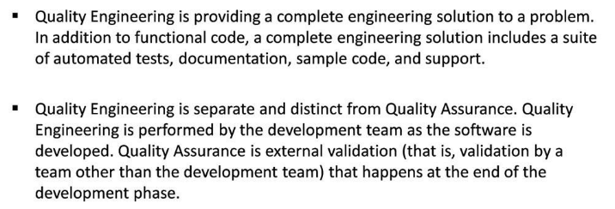
In the coming slides, we will learn the key areas of Build and Deployment Process
Build and deployment process
In the Build and deployment process, we can see the following stages:
- Initial build and deployment of the solution
- Build and Deployment with Installation guide
- Automated build and deployment
- Installing the Beta 1 version to TEST
- Installing the RC1 version to TEST
- Installing the RC2 version to TEST (If required)
- Installing the V1.0 release to PROD
Initial build and deployment of the solution
The Key steps involved in the initial build and deployment solutions are:
Point 1. Using their local environments, members of the Development team add new code – or modify existing code – and subsequently check the code into the source control system.
Point 2. On the Build Server, the entire solution is labeled in the source control system to “snapshot” the exact state of the solution at the point in time just prior to the build. The label includes the version number (for example, 1.0.1.0 in the case of the initial build).
Point 3. Using the label established in the previous step, all of the source code for the solution is copied from the Source Control Server to the Build Server, thereby ensuring that what is compiled into a specific version of the solution is based on the corresponding version of the source code in the source control system.
Point 4. The solution is then compiled on the Build Server.
Point 5. Next, the output of the build is copied from the Build Server to the Release Server (in a subfolder on the Builds share). The location of the build output on the Release Server includes the build number (e.g. 1.0.1.0) as well as the build configuration such as Debug or Release (note that the build configuration is not illustrated in Figure 1). The initial build often contains nothing more than the compiled code, which may be a group of assemblies (i.e. a number of EXE and/or DLL files) or a setup package (i.e. an MSI or CAB file) but most likely does not have an installation guide or installation scripts.
Point 6. The solution is then installed by the Development team into the Development Integration Environment (DEV). This initial installation is typically performed manually (for example, by copying files, registering assemblies, modifying the server configuration, and/or interactively stepping through a setup program).
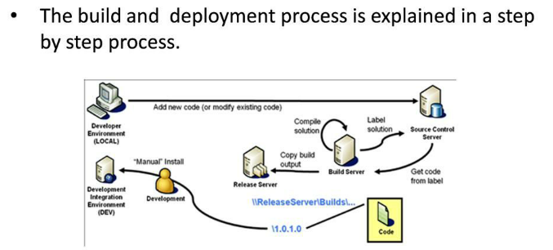
Build and Deployment with Installation guide
The steps performed in the initial build are repeated in this subsequent build. The key difference is the inclusion of the installation guide (which documents the manual steps performed by the Development team during the initial deployment). The new build (in this example, 1.0.2.0) is then deployed to the DEV environment by following the installation guide.
While this deployment process is functional -- in that a new build of the solution is successfully deployed to the DEV environment -- it requires too much manual effort to sustain the process.
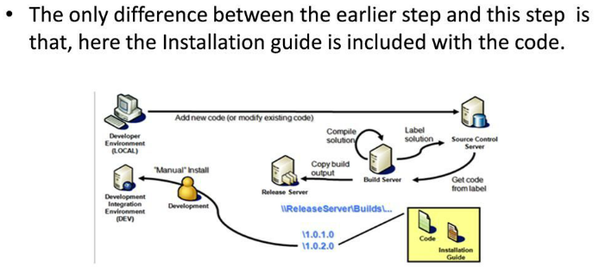
Automated build and deployment
The automated installation process actually installs version 1.0.3.0 but installs it from the Latest folder on the Release Server. The contents of the Latest and 1.0.3.0 folders are identical. Using this mirrored structure greatly simplifies the automated installs of the latest build into the DEV environment.
The build illustrated here includes install scripts, in addition to the build output (i.e. compiled code) and the installation guide (which has been updated to specify the install scripts to be used for installing the solution). These install scripts are a key piece of the automated installation process -- and subsequent “manual” installs into other environments.
This process does not require any manual intervention and can therefore be performed on a scheduled basis (à la, the “daily build”) or ad hoc, simply by executing the scheduled task as desired. Each subsequent build includes the source code changes checked-in to the source control system -- thus incorporating new features and bug fixes -- and is automatically installed into the DEV environment -- thus providing visibility to all team members on the progress of development.
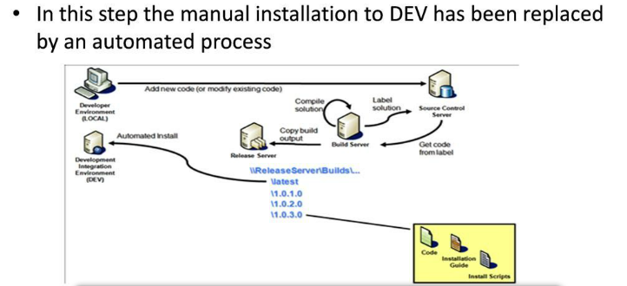
Installing the Beta 1 version to TEST
While Installing the solution to the Test environment,
The build selected by the Test team does not necessarily correspond to the latest build. It is common for a later build of the solution to be running in the DEV environment, as a result of the daily build.
At one point in time, the version of the solution selected by the Test team was automatically installed to the DEV environment – as indicated by the dashed line in the figure.
Before installing the selected build to the TEST environment, the corresponding label in the source control system is annotated – as indicated by (Beta 1). This allows the Development team to quickly get the version of the source code in order to debug problems encountered in the TEST environment.
The Test team installs the solution in the TEST environment by following the installation guide (which details the install scripts and configuration steps to be used).
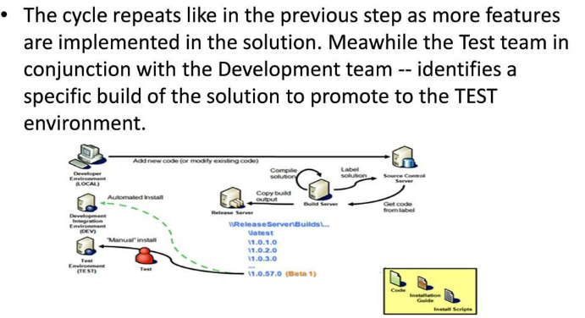
Installing the RC1 version to TEST
After installing the RC 1 version to test. If issues are discovered with the RC1 build, it may be necessary to promote yet another build to the TEST environment which will be explained in the next stage.
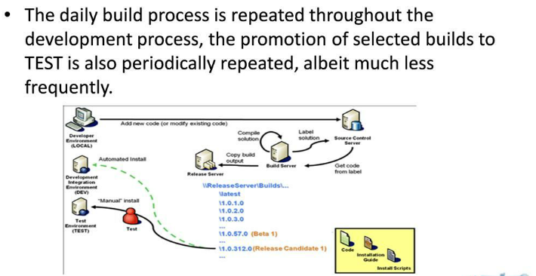
Installing the RC2 version to TEST (If required)
Assume that the second release candidate (version 1.0.379.0) passes all of the test cases. The final step is to install the solution into the production environment.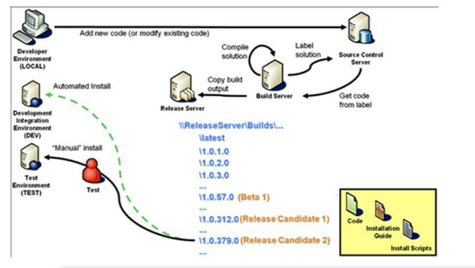
Installing the V1.0 release to PROD
Key concepts in this stage are:
Release Management – not the Test team – is responsible for installing the solution into the PROD environment.
The build installed into PROD was previously installed and evaluated in the DEV and TEST environments.
Before installing the selected build to the PROD environment, the corresponding label in the source control system is annotated – as indicated by (V1.0). The Development team also creates a branch in the source control system from this version in order to support “hotfixes” (patches) and minor releases (e.g. V1.1).
Release Management installs the solution in the PROD environment by following the installation guide (which details the install scripts and configuration steps to be used) just as the Test team did when installing the solution into the TEST environment.
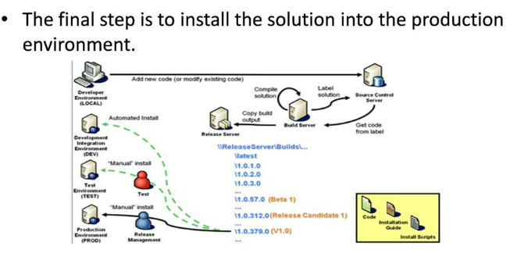
Let us now see what is the importance of continuous Integration in Quality Engineering and How does CI plays an important role in QE.
Continuous Integration
The single most important tooling for QE is the Continuous Integration (CI) environment.
In software engineering, continuous integration (CI) implements continuous processes of applying quality control — small pieces of effort, applied frequently.
Continuous integration aims to improve the quality of software, and to reduce the time taken to deliver it, by replacing the traditional practice of applying quality control after completing all development.
Continuous Integration (CI) is one of the baseline framework approach in recent developments of quality engineering and automation.
CI framework can be leveraged in project life cycle models like Water fall, Agile etc
Normal pressures of the day will eventually keep the most diligent developer from performing manual steps such as running all the unit tests, checking code coverage, checking profiling information, performing static analysis on source code, and so on.
In the QE process, these tasks are automated in a CI environment. In a nutshell, the CI environment pulls the latest source code from the version control system (Clear Case, SVN,...), compiles it, runs the static analysis tools, runs all the tests, logs the results, then starts over and does it again, forever.
Automated tools such as Cruise Control, Jenkins, Hudson, Bamboo, BuildMaster, AnthillPro or Teamcity offer this scheduling automatically.
Advantages
CI integration is very advantageous in the following aspects:
- CI provides great insight into the quality of the code throughout development.
- It improves team productivity.
- It is indispensable once in place.
- It is much easier to correct functional
- Problems that are detected within an hour of being introduced, than it is when they are detected several days or weeks later.
Disadvantages
In spite of many advantages in CI, there are also few disadvantages too, which are:
- Initial setup time required is more
- Well-developed test-suite required to achieve automated testing advantages
- Hardware costs for build machines can be significant.
Many teams using CI report that the advantages of CI well outweigh the disadvantages. The effect of finding and fixing integration bugs early in the development process saves both time and money over the lifespan of a project.
Let us now discuss briefly on the Code Review Techniques.
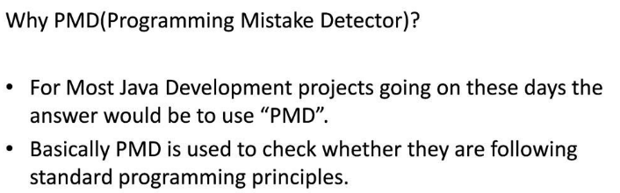PMD is Programming Mistake Detector which is used by most Java development project to check the standard programming principles.
PMD competes with many tools like Checkstyle, FindBugs, Hammurapi, Soot, Squale etc.
Usage PMD
PMD identifies potential problems in the code like:
1. Possible bugs - empty try/catch/finally/switch statements
2. Dead code - unused local variables, parameters and private methods
3. Suboptimal code - wasteful String/StringBuffer usage
4. Overcomplicated expressions - unnecessary if statements, for loops that could be while loops
5. Duplicate code - copied/pasted code means copied/pasted bugs.
Configuring PMD for Eclipse:
Below are the steps to configure PMD for Eclipse
1. Start Eclipse.
2. Select the Help>Software Updates>Find and Install... menu item.
3. Select "Search for new features to install" option and click Next.
4. Click New Remote Site...
5. Enter the URL http://pmd.sourceforge.net/eclipse
6. Select this new site in the Sites to include in search list and click Next.
7. Select PMD for Eclipse 3 and Apache Xerces in the "Select the features to install" list and click Next.
8. Accept the terms of the license agreements and click Next.
9. Verify that the install location is your Eclipse installation directory, otherwise select the correct one, click Finish.
10. A warning appear telling the feature is not signed. Ignore and click Install to continue.
11. Accept to restart the workbench to load PMD into the workbench.
12. Right click on java file and try to check code using PMD.
Find Bugs and Check Styles
Find Bugs: FindBugs is a static analysis tool that examines your class or JAR files looking for potential problems by matching your bytecodes against a list of bug patterns.
With static analysis tools, you can analyze software without actually running the program.
Check Style: Checkstyle is a development tool to help programmers write Java code that adheres to a coding standard. Checkstyle can check many aspects of your source code. It automates the process of checking Java code to spare humans of this boring (but important) task. The main functionality of Checkstyle is to check code layout issues, to find class design problems, duplicate code, or bug patterns like double checked locking.
What is Unit testing? What has Junit got to do with Unit testing? Let us now see that in this chapter
Unit testing: Unit testing is a method by which individual units of source code are tested to determine if they are fit for use.
Roughly equivalent to chip-level testing for hardware
Its testing done to each module, in isolation, to verify its behavior
Typically the unit test will establish some sort of artificial environment and then invoke routines in the module being tested
It then checks the results returned against either some known value or against the results from previous runs of the same test (regression testing)
When the modules are assembled we can use the same tests to test the system as a whole
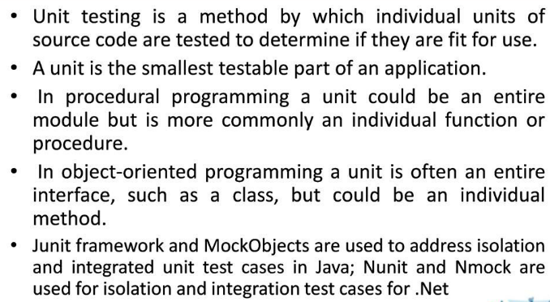
Why do we need Unit testing?
Faster Debugging: Unit tests smaller amounts of code, easily isolating points of error and narrowing the scope for errors.
Faster Development : Less time debugging with unit tests. Encourage aggressive refactoring resulting in better design and easier maintenance. Adding enhancements can be performed with confidence that existing behavior of the system continues to operate in the same manner.
Better Design: As mentioned before, unit testing encouraging more refactoring. Unit tests make developers focus more on the contracts of a class and those classes that might use it
Excellent Regression Tool : Major refactoring's and restructuring of the code can be performed.
Reduce Future Cost: Unit testing is an investment in the project. It takes time to ramp up, but in the long-term provides a useful basis for the project.
Some Unit testing Methodology:
- Selection of units: We selected only the most important functional and critical classes
For formal unit testing. In the test environment we used, a unit for unit testing is a class.
- Test Scripts: As we used JUnit for unit testing, the test scripts were java programs
And each test case corresponded to a method in these java programs.
- Fixing of Defects: The programmer fixed the defects found.
Unit testing was successfully complete only if the script executed without any defects.
- Test Script Enhancement: As testing proceeded, some new test cases were added.
This was done by adding new test methods to the testing program.
Design of Junit:
- JUnit is designed around two key design patterns: the Command pattern and the Composite pattern
- A TestCase is a command object- any class that contain test methods should subclass the TestClass class.
- A TestSuite is a composite of other tests, either TestCase instances or other TestSuite instances.
What is TestNG?
TestNG is a testing framework inspired from JUnit and NUnit but introducing some new functionalities that make it more powerful and easier to use. All these functionalities will be dealt in a separate course.
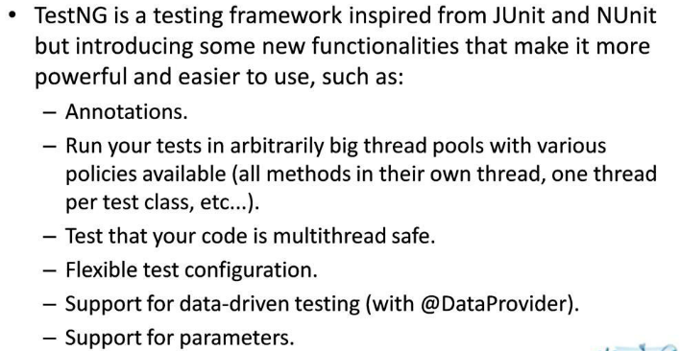
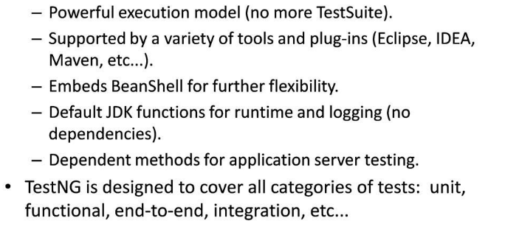
Let us now briefly discuss what is BDD(Behavior Driven Development)
Behavior-driven development is about implementing an application by describing its behavior from the perspective of its stakeholders.
Why BDD?
BDD was derived to avoid problems related to TDD, Make development customer focus, Avoid communication gap and translation mistakes and Executable Documentation.
Principles of BDD:
- Enough is enough
- Deliver stakeholder value
- It’s all behavior
Basics of BDD
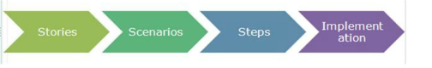
Story
Role, Feature, Benefit
» I – Independent
» N – Negotiable
» V – Valuable
» E – Estimable
» S – Small
» T – Testable
The above example will explain about a customer searching for a book using the book title .
Acceptance criteria:
Describes the functionality of the a User story like
» State an intent not a solution
» Are independent of implementation
» Are relatively high level
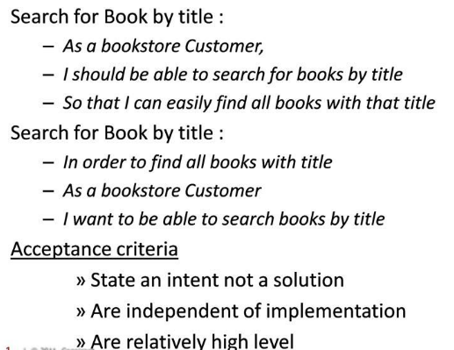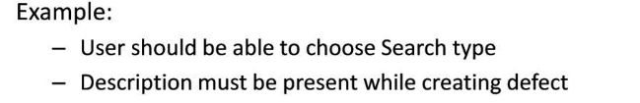
Gherkin is a continuous Integration tool
Business Readable DSL
Defines a grammar to provide unique understandable format
Helps to create executable documentation
Implemented in different BDD tools
» Cucumber , Spec Flow , cucumber-JVM, Cuke4Nuke, RSpec

